

Oroua Downs School

Charter and Improvement Plan

2023-25

|  |  |  |  |
| --- | --- | --- | --- |
| Motto | | | |
| *Whāia te pae tāwhiti –* Pursue the distant horizon | | | |
| Vision | | | |
| At Oroua Downs School we aim for our students to be responsible, creative and active thinkers that have the skills to confidently succeed in, and adapt with, an ever changing world.  **At Oroua Downs School all students will strive to:**  *recognise and pursue their talents*  *be reflective and valuable contributors to the community*  *have strengths in Literacy and Numeracy*  *be active, curious learners*  *have strategies to support their wellbeing*  *have an awareness and appreciation of their local environment.* | | | |
| Values/ Virtues | | | |
| Mahitahi – Teamwork | Kairangatira – Excellence | Mana – Respect | Auahatanga - Creativity |
| Principles | | | |
| We are guided by the Principles of the Treaty of Waitangi and the New Zealand Curriculum | | | |
| Our Place | | | |
| Oroua Downs School is a well-established country school which has delivered primary education to Year 0 – 8 students for over 100 years. The school is situated on SH 1, 42 kilometres west of Palmerston North and 12 kilometres north of Foxton. The locality of the school ensures a diversity of students and families from Himatangi Beach, Foxton and Foxton Beach communities, lifestyle blocks, and farms. The majority of students travel to school by bus.  In 2023, we have five classrooms. We have a shared collaborative Junior Hub with students from NE to year 3. We are running two parallel classes of year 6-8 and one class of year 4-5.  Core learning areas are conducted in the morning blocks, the entire school learns these area at the same time to ensure that we best cater for the needs of our learners, students can work in different classrooms, utilising teacher skills and specific initiatives to focus on student achievement.  Our Junior school are introducing ‘Structure literacy’ into our learning programmes, with a sequenced and structured approach that suit many different learners. Play based learning philosophies are utilised throughout classrooms up to year 3. We encourage our students to develop their Agency by knowing their strengths as learners and the areas that they need to focus on to make progress. We encourage student to follow their passions and interests when learning and students often collaborate and contribute to the design of their learning.  We have four teacher aides that work within the classrooms and also providing 1-1 that addresses specific learning needs. Our teacher aides have been trained in many programmes to support can be catered for each learner needing extra Support. Oroua Downs also has a SenCo that communicates between home, school and agencies, while also providing additional programmes to be implemented by the Teacher Aides. Agencies that are accessed to support student achievement and wellbeing are Speech Language Therapy, SWiS, RTLB and MoE (Special Education and Behavioural Services).  Oroua Downs School is part of the Te Oro Karaka Tahi Kāhui Ako. Oroua Downs support the achievement challenges and have aligned these challenges to our strategic plan.   * We have a clear vision, Partnering to Nurture and Unleash Potential - Te mahi tahi ki te whakaputa i te kaha * We aspire for all students, regardless of background, culture or gender, to be achieving at or above their expected level or their age in all curriculum areas; particularly Reading, Writing and Mathematics. | | | |
| Our Learners | | | |
| Our students voice is valued at Oroua Downs.  We have a House system and student leaders that gather to hear voice and share successes of our students. Leaders communicate to our community via, newsletters and our learning journey platform SeeSaw. Student reflections are included when reporting to parents and we conduct student led conferences.  Student voice also contributes of learning experiences throughout the year. Student leaders help plan our behaviour celebration day, some cluster sports events and lunchtime activities, as well as leading assemblies. Students in years 4-8 also participate in our Badge System. Students earn points, across five categories to earn one of three four levelled badges.  Our students conduct ‘Passion Project’ learning, this allows them to follow their interests and involve members of the community. We have improved our localised curriculum to include opportunities to grow students confidence with House Challenges, Passion Projects, Play-Based Learning, Sporting and Cultural events within our Te Kawau Cluster and developing a garden area for sustainable practices that support our environment.  Oroua Downs also engages in agencies to support the learning and wellbeing of our students that require that support.  We monitor student attendance via our SMS eTap and contact parents/caregivers when querying absences and communicating concerns. We have also enlisted the services of the Truancy Officer when required.  Oroua Downs also engages in agencies to support the learning and wellbeing of our students that require that support. | | | |
| Self Review | | | |
| This Charter will be reviewed at Board level in our first meeting February 2023, completed by the Principal. Community consultation will be on going as part of our self review.  Review of progress against our goals are completed via BOT meeting. Reporting against strategic goals is monitored in Leadership Reports, twice termly at BOT meetings. | | | |

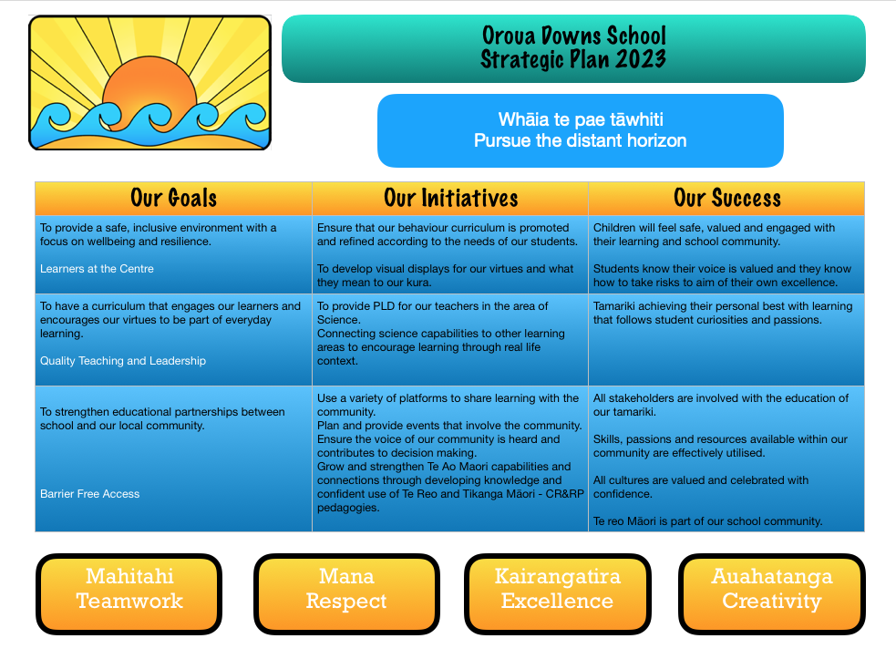

Improvement Plan

|  |  |  |  |  |  |  |
| --- | --- | --- | --- | --- | --- | --- |
| Background | | | | | | |
| 2022 saw a successful year of increased academic outcomes.  The data table below shows the improvements for all students, across all age levels. All students are included in this data.   |  |  |  |  |  | | --- | --- | --- | --- | --- | |  | | **Below  Expectation** | **At Expectation** | **Above Expectation** | | **Maths** | Term 1 | 62 | 38 | 0 | | Term 4 | 14 | 74 | 11 | | **Reading** | Term 1 | 22 | 78 | 0 | | Term 4 | 7 | 68 | 25 | | **Writing** | Term 1 | 57 | 41 | 2 | | Term 4 | 16 | 79 | 6 |   There are cohorts that we will be closely monitoring (above ‘normal’ processes):  Year 7 students – in writing – there are 9/14 students that are working below expectation on the cusp of underachieving in writing.  Year 7 students – in math – there are 8/14 students that are working below expectation on the cusp of underachieving in math.  The year 4 cohort have made great progress this year in math, we will closely monitor to ensure this is maintained.  The year 4 cohort has a wide range of achievement (in reading), this group also has had the most negative impact over the past few years with COVID and teacher changes, we will closely monitor this group.  Reading showed the most improvement, with the least number of students achieving below expectation – we will closely monitor this curriculum are to ensure that the increased academic outcomes are maintained and/or improved. | | | | | | |
| Our Plan | | | | | | |
| **Annual Goals** | **Background** | | | **Core strategies for achieving goals** | | **Time** |
| To provide a safe, inclusive environment with a focus on wellbeing and resilience. | We have PB4L established in our kura. Students and whanau understand our behaviour curriculum.  We have had many students enrol with extra challenges, this has highlighted the need for this to be a living breathing document that adapt for our students. | | | * Review and adjust behaviour curriculum matrix as needed. * Share with community to get feedback * Analyse behaviour data weekly to identify trends, repeated challenges and to inform to teaching of a focus. * Ensure that new parents get a copy of our Behaviour Matrix * Ensure that the expectations are visible and accessible for all * Review systems for rewarding positive choices and adapt as required. * Complete training with new staff members as needed * Monitor incidents and report concerns to BOT * Make expectations visible through design of posters for the school. | | On-going |
| **Outcome:** *Children will feel safe, valued and engaged with their learning and school community. Students know their voice is valued and they know how to take risks to aim of their own excellence.* | | | | | | |
| To have a curriculum that engages our learners and encourages our virtues to be part of everyday learning. | Our tamariki have expressed and interest and demonstrated a passion fir Science.  We have engaged with House Of Science for Locally Funded PLD for the year.  It is aimed that we will encourage engagement with literacy and numeracy under the umbrella of science with an eye on improved outcomes in the core learning areas. | | | * Working with PLD provider to increase teacher capability and confidence within the learning area of Science. * Develop a bank of resources and equipment to support and develop science learning. * Gather student voice as to their own growth within this learning area. * Develop a yearly plan based on student voice and resources. * Increase understanding and use of the Science Capabilities across curriculum areas. * Engage EOTC and other professionals to support Science learning both in and out of the classroom * Encourage and provide resources for an environmental group to establish themselves within the school. | | Terms 1-3  50 hours |
| **Outcome:** *Tamariki achieving their personal best with learning that follows student curiosities and passions.* | | | | | | |
| To strengthen educational partnerships between school and our local community. | We have introduced SeeSaw as part of our ‘real time’ reporting. Engagement of this has been varied but it is improving. With any changes, it takes time to get full buy in. We have families that engage with SeeSaw regularly and some that don’t. In the past we have written a report as well as having digital portfolios, this year it will change, the expectation is there for engagement and this is slowly increasing. | | | * Have every child create a digital portfolio using the SeeSaw tool. * Have all families connected to a portfolio * Use digital portfolio to share current learning specific to the individual and also general sharing of class learning experiences. * Encourage students to develop agency and post of their own portfolio, with explanations about learning and self-reflections. * To increase Parent/Child hui, with one each term and with a specific focus:   Tm 1: Building relationships and getting to know our learners.  Tm 2: Goal Setting and how can help at home  Tm 3: Review Goals and reset  Tm 4: Looking forward to 2024   * Use digital tools like Skoolloop and Etap to communicate, inform and celebrate. * Use FB to celebrate successes of students * Board to invest in the purchasing of this license * Invite community members into the school to share talents, skills and expertise. * Board to host events that | |  |
| **Outcome:** *All stakeholders are involved with the education of our tamariki. Skills, passions and resources available within our community are effectively utilised. All cultures are valued and celebrated with confidence. Te Reo Māori is part of our school community.* | | | | | | |
| For all students, regardless of background, culture or gender, to be achieving at or above their expected level or their age in all curriculum areas; particularly Reading, Writing and Mathematics. | We have quite a transient population and at times it can be quite challenging to get traction for some learners. We have also discovered that our students are presenting with more challenges and adaptation is very much needed to suit the academic abilities of our students.  The immense need for pastoral care has increased and this can be a barrier for learning, we treat every student as an individual and their needs are known and a priority.  As a staff, we have noticed the increase of students coming to school with extra anxieties and worries, this does impact on their ability to effectively engage with their peers, their teachers and their learning. It is due to this that we are constantly having to adapt and challenge existing ‘norms’ for success. | | | * Provide quality teaching and learning in the core areas. * Provide extra support in classroom where needed when possible. * Board to fund teacher aides to support classroom programmes. * Agencies involved to support students when and where needed – RTLB, SWiS, MoE, SPLT, Counsellors, Psychiatrists, Truancy Officers, Occupational Therapists, Mental Health, DHB Health Nurses and Social workers, specialist teachers (ORS). * Ensure that partnerships and communication between home and school are strong, timely and meaningful. * Engage with the Community to find supports and their wishes for our tamairki * Monitor progress of students, review status and out the necessary supports in place. * Whole staff moderation to ensure common language used and understanding/expectations are clear. * Utilise teacher strengths, share expertise and knowledge to increase capabilities and confidence within staff. * Engage in Professional Learning – based on school focus and also individual interests/passions. * Use student voice to help design learning experiences. * To grow our students through leadership and experiences outside the classroom. | | On-going |
| **Outcome:** *That all children experience quality teaching and learning that leads them to academic successes.* | | | | | | |
| Annual Targets | | | | | | |
| **All students will be monitored for academic progress, pastoral and health care needs.**  **All students will have behavioural needs monitored and supports put in place if and when needed.** | | | | | | |
| **Target Goals** | | **Background** | **Core strategies for achieving goals** | | **Time** | |
| *For our year 8 (2023) students to have academic supports in place to best prepare them for High School.* | | Many from this cohort have found achieving academic success a challenge. Many of these students have had 1-1 and small group support in the areas of literacy and numeracy. Progress has been made, however, it has not been accelerated or sustained.  *Year 7 students – in writing – there are 9/14 students that are working below expectation on the cusp of underachieving in writing.*  *Year 7 students – in math – there are 8/14 students that are working below expectation on the cusp of underachieving in math.* | Engage a qualified teacher to take a short course of lessons in both literacy (reading), specifically designed for individual needs.  Support students where needed with pastoral care and other agencies.  Engage ‘parent helpers’ to support with reading mileage with a focus on fluency and comprehension.  Hold school wide competitions and activities to engage students with recreational reading.  Hellz Pizza challenge, House Challenges, Student Vs parent competitions eg – photos pf reading competition and display, reading mileage for House Points.  Provide STEPS as an options to support literacy learning. | | Term 2  On-going  Term 2-4  On going  On going | |
| **Target Goals** | | **Background** | **Core strategies for achieving goals** | | **Time** | |
| *To monitor the academic progress of the year 5 (2023) group* | | This cohort of students have had the most disruptive time in their schooling thus far. They have been impacted upon by COVID and also challenges with teachers – as far as consistency is concerned – we had staffing challenges and this group of students has to endure many changes during one year.  This cohort did make a lot of progress in 2022, however, we need to monitor closely to ensure that accelerated progress is maintained. | Put a teacher aide in this class to support the learning needs of these students – especially during literacy and numeracy.  Implement math support programmes to boost number knowledge and confidence for those that are in need of this**.**  Provide a STEPS license for those that require support with writing.  Ensure we have strong communication pathways between home and school to ensure we gain the best educational outcomes for these students. | | Term 1-2 – review the need end term 2 and adjust teacher aide to suit.  Term 2-3 - review the need end term 2 and adjust teacher aide to suit.  On-going throughout the year.  On-going:  Utilising the digital platform of SEESAW to ensure parents have up to date information about the progress of their children and how parents can help learning at home. | |